UNLOCK the deployment lock in bosh

# introduction

BOSH has a lock over each deployment - you can only perform one deployment per deployment name at a time. So if you cannot cancel a task that has locked a deployment, then you cannot perform a subsequent task.

Look at this. When we tried to recreate the VM, we had hit a lock.

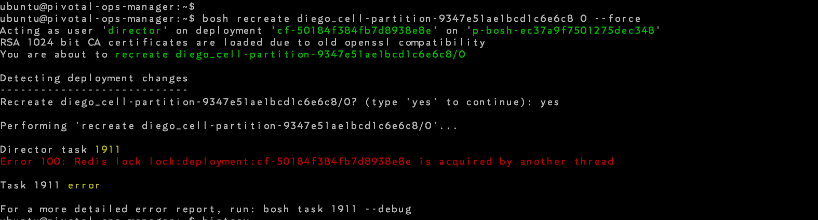

Go ahead and get started.

## Login to bosh director vm

From Ops Manager: ssh [vcap@3.3.89.13](mailto:vcap@3.3.89.13)

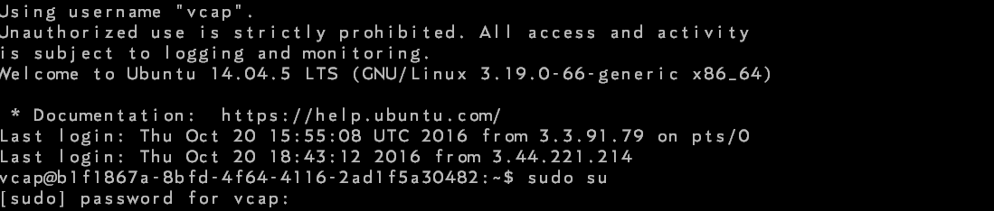

## Export redis bin path

* /home/vcap# export PATH=$PATH:/var/vcap/packages/redis/bin



## login redis cli

* /home/vcap# redis-cli -p 25255 -a redis



## check for locks

* keys "lock:*"

Upon password prompt, provide redis password.

* AUTH <redis_password>

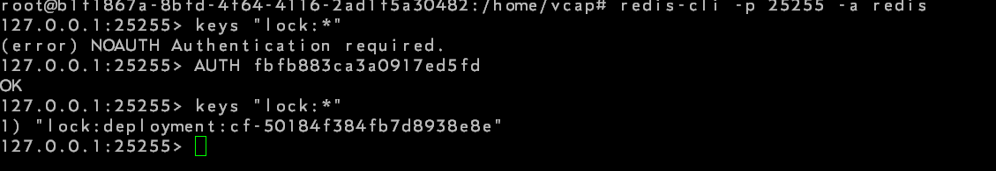

## Delete lock

* del <lock>

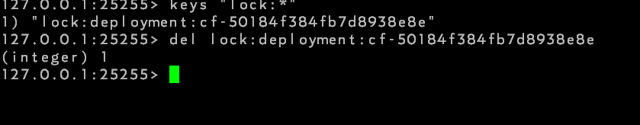

# conclusion